**Name: Akshay Bhala**

**Netid: abhala**

**Assignment 9**

1. **Excel:**
2. **Connection to Rolap:**

**Units in Stock for each product segregated by Categories**

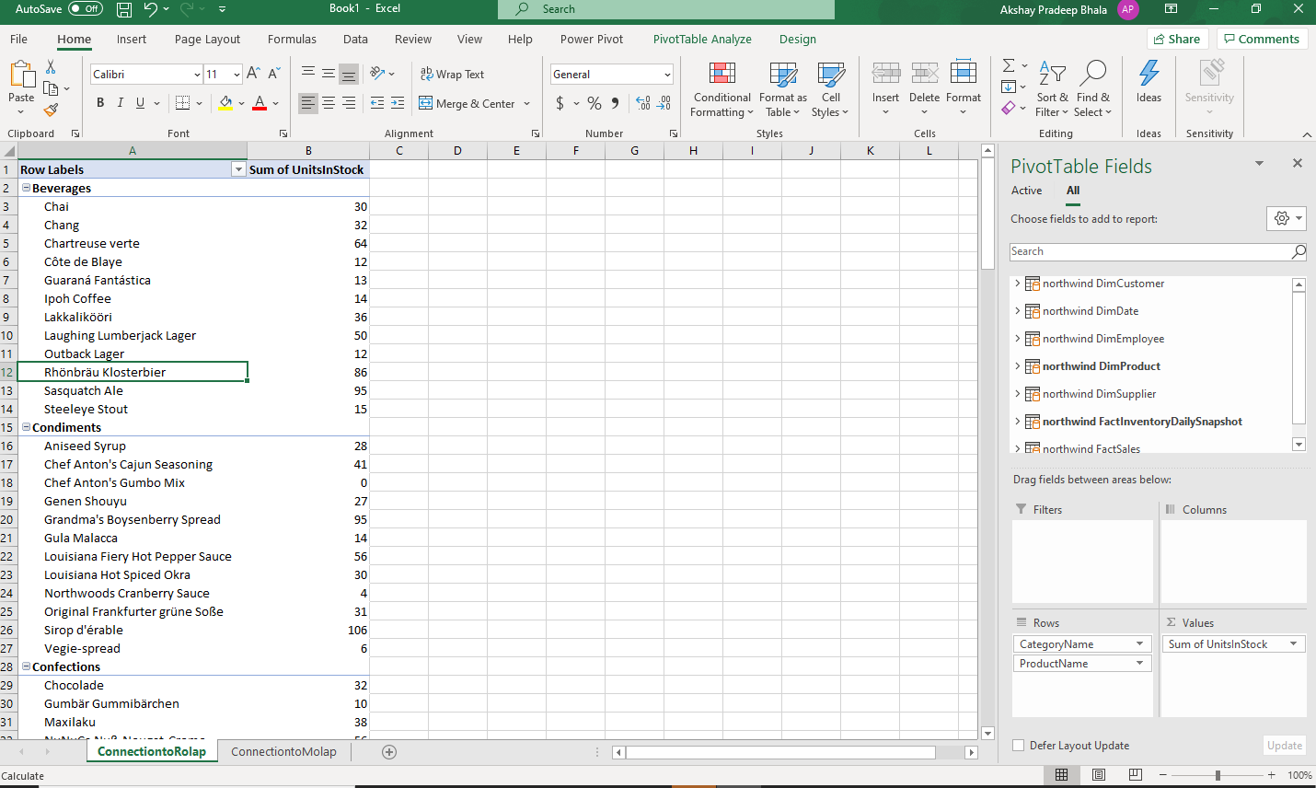

1. **Connection to Molap (Northwind Sales cube created by us):**

**Sales Count for each week day**

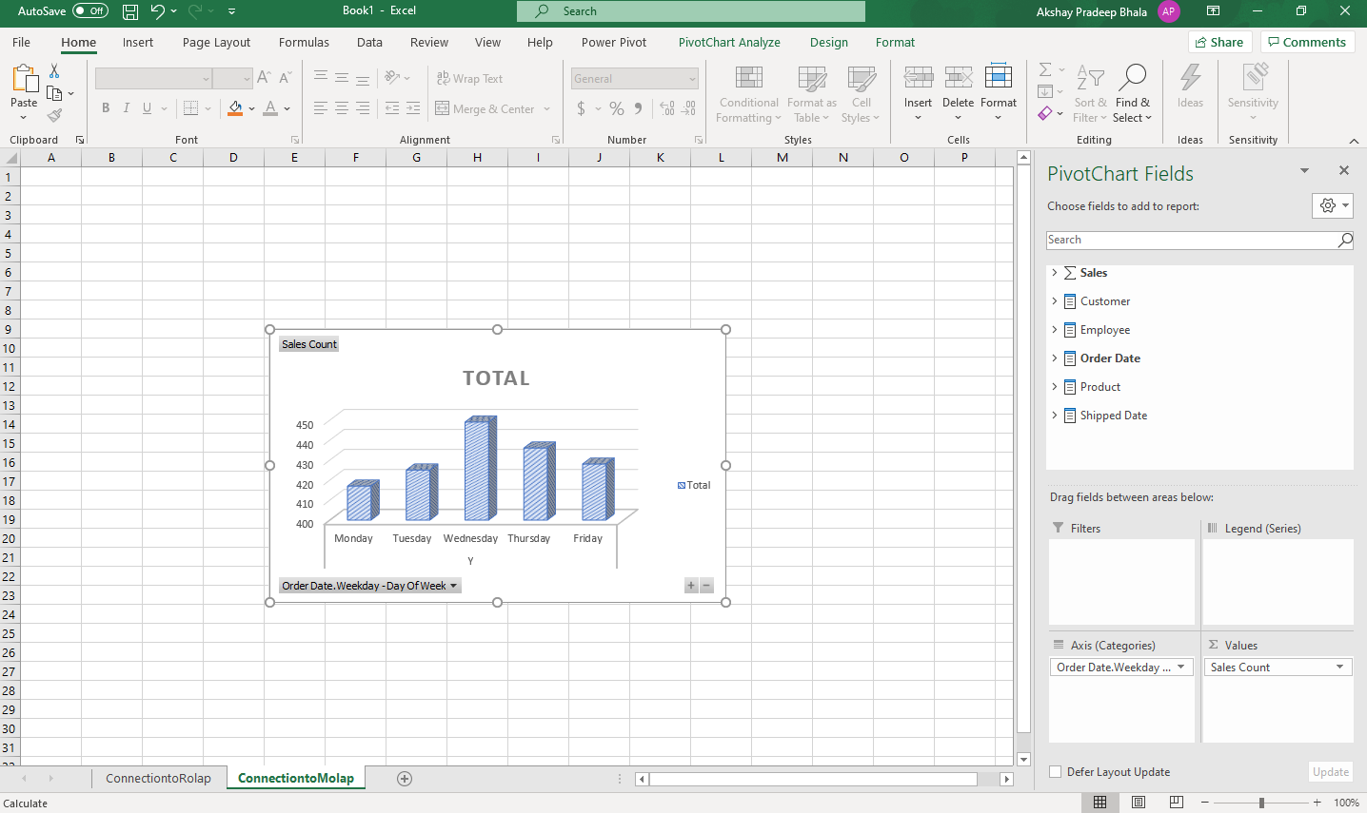

1. **PowerBi:**
2. **Connection to ROLAP:**

**Units in Stock for each Category**

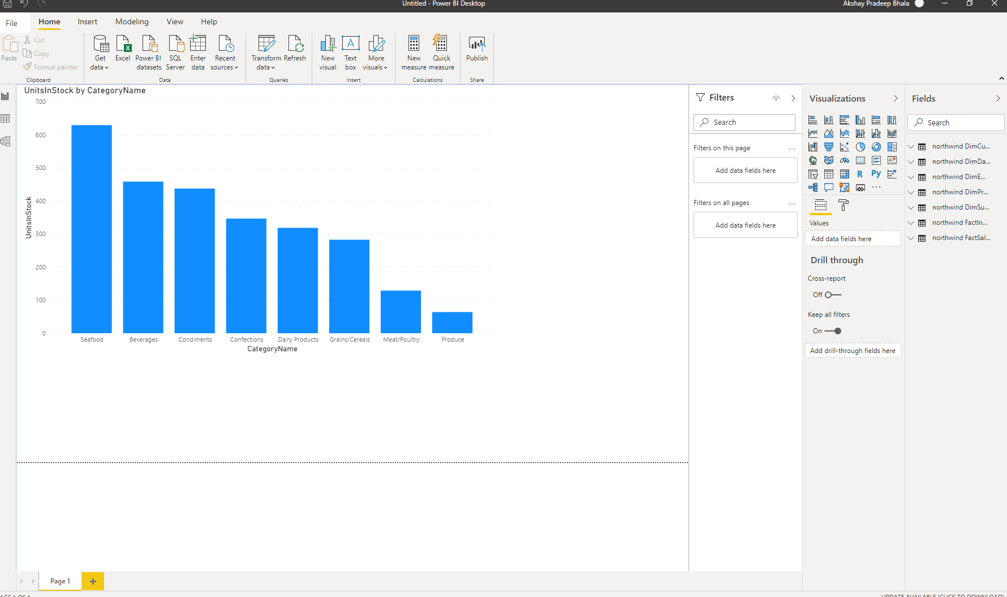

1. **Connection to MOLAP (Northwind Sales cube created by us):**

**Quantity per product**

